Tasks to complete the project

The team has chosen to according to the agile manifesto. This means that we will iterate through the tasks. We will continuously review our work during to project and will have a working product by the end of each iteration. The following iteration we will revise the old and add new features to the product. Each iteration will hold a number of tasks that will be described below. These tasks are fixed and during the project we will iterate through these. We plan to have three iterations.

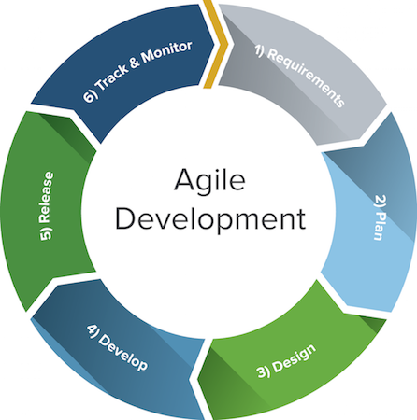

1. Requirements
   1. Elicitation
   2. Validation
2. Plan  
   The project members meet and work on identifying features for the project. The goal here is to break down everything into smaller chunks which will be easier for the team to handle. The team must then prioritize what work has to be done in each iteration.
   1. Product
   2. Project
   3. Version control
   4. Release planning
   5. Documentation planning
3. Design  
   The design is based on the requirements and the planning previously done. Here the team concludes what the product will look like and how it shall work. Important parts for our project is the interfaces needed between the various parts of the system. Here we shall also define and design the test plan for the product.
   1. Interfaces
4. Develop  
   This is the actual development. In this phase assigned developers will code features while conducting minor test to make sure that each feature works independently.
   1. Back-end
   2. Front-end
   3. Testing
5. Release  
   In the release phase the team will conduct major testing and evaluation of the product. Emphasis here is on making sure that the individual features will work together with the other features developed. Since we do not have an actual customers the team will need to validate that the product meets the goals for each iteration.
   1. Pre-release testing
   2. Release validation
6. Track and Monitor  
   We distinguish tracking and monitoring in our project. These activities will be conducted throughout the project and below we describe how we plan to work with these.
   1. Track - Goes back in time and is meant to form a basis for following up what has been done. The main objective here is to make sure that we do not repeat past issues.
   2. Monitor - This is done in real time and the goal here is to prevent any issues from rising.